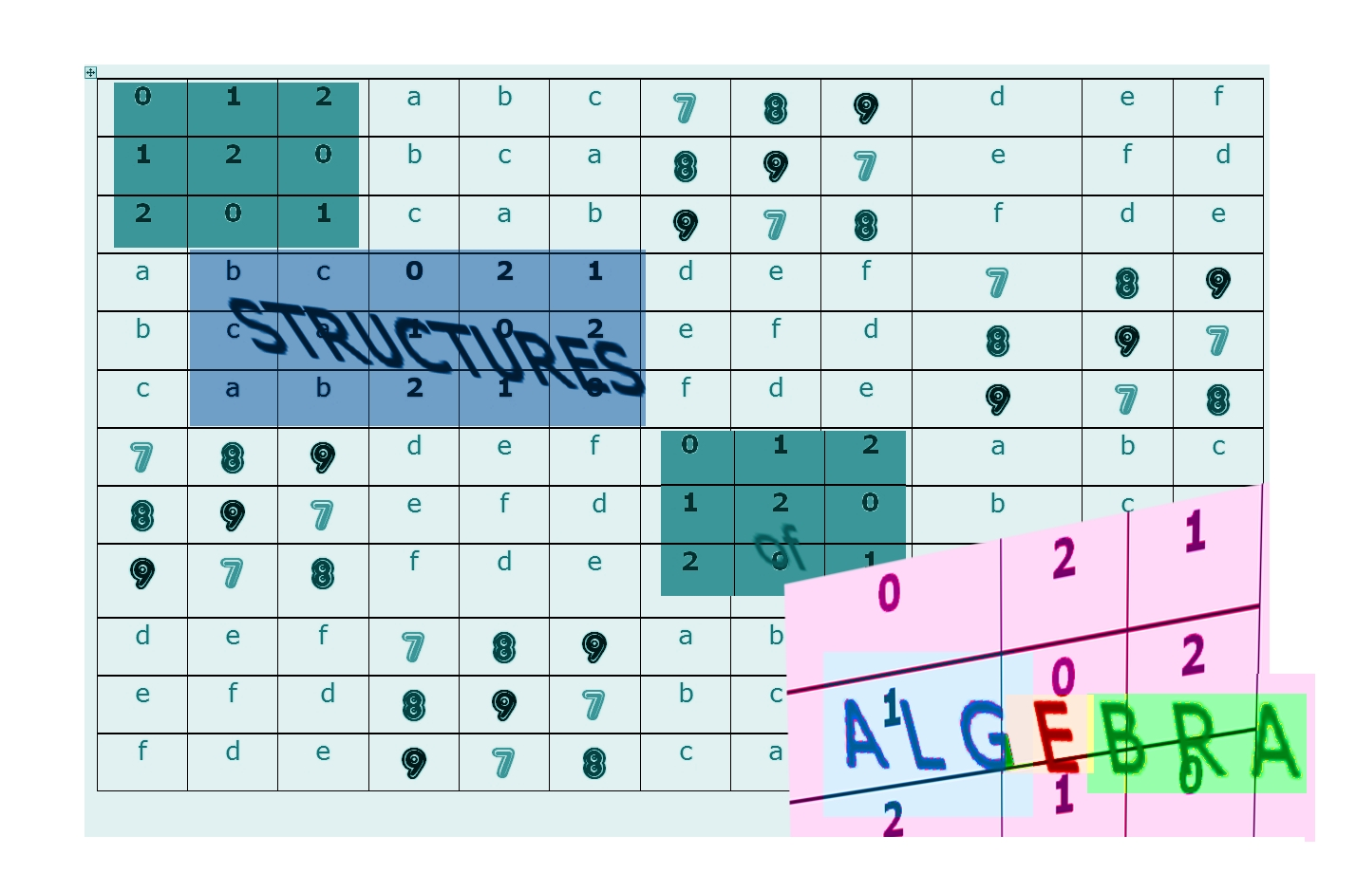

S T R U C T U R E S
of

ALGEBRA

Dedicated to Arno Feringer

!

Knights in white satin
never reaching the end …

…

...

they will never, never understand

Just what U wanted to be,



Eric Burdon

Knights in white satin

Mathematical

SUDOKU

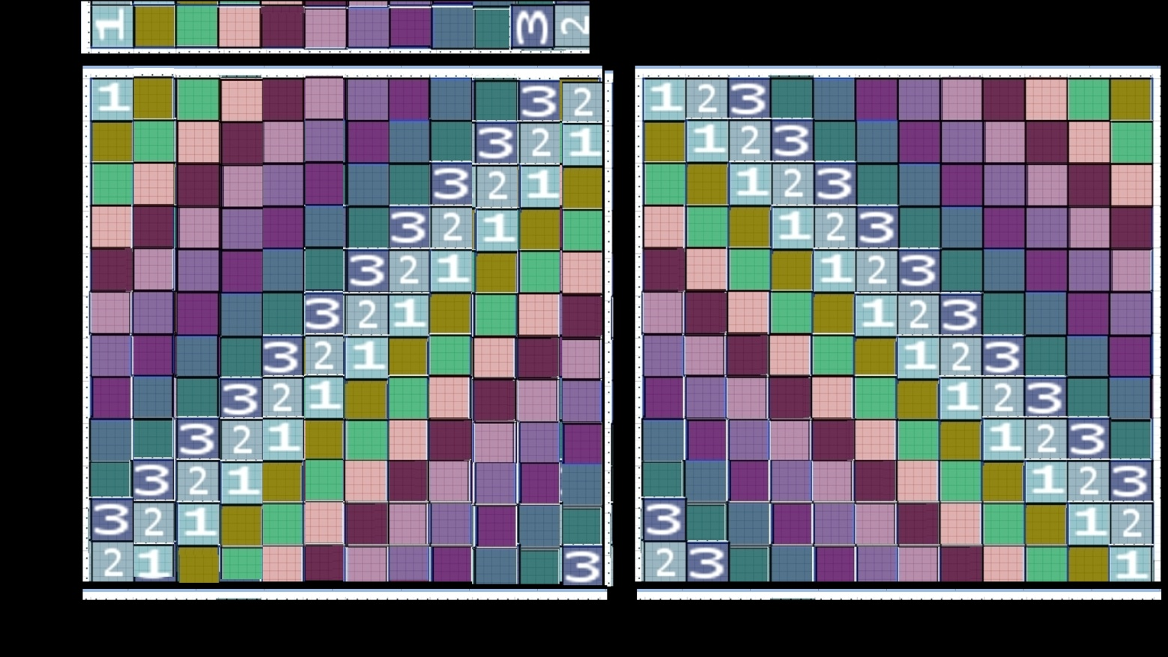
The cyclic group C₁₂
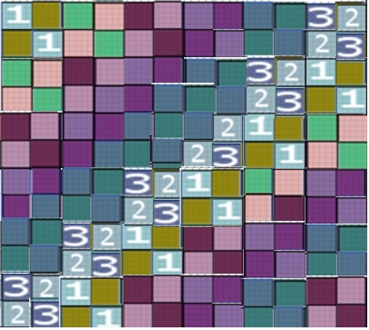
These three coloured groups are abelian or commutative
(symmetry axis is the main diagonal)
But do they have the same structure too?

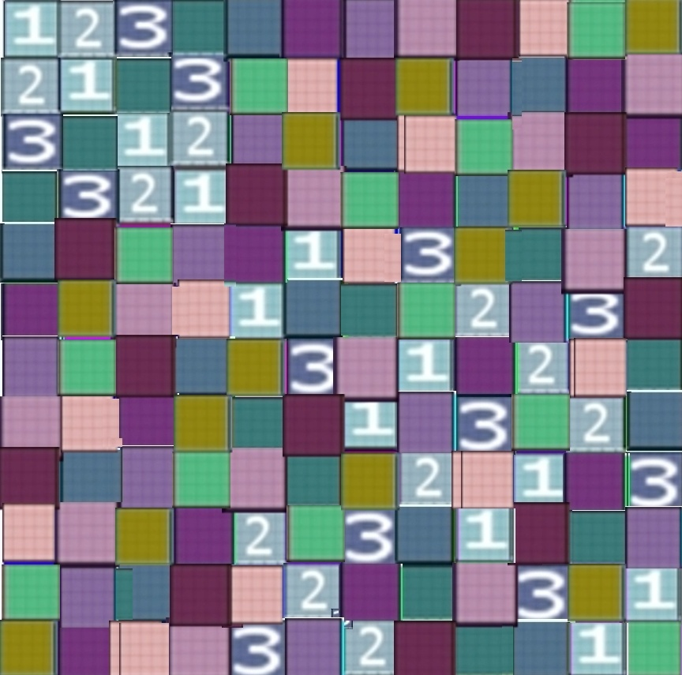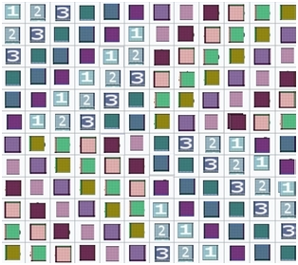
In any case, there is yet another commutative colour group not isomorphic to the cyclic C₁₂, with structure C₂×C₆; and there are even three more distinct group-structures with 12‑elements, that are not commutative (not abelian), namely C₄×C₃, C₂×S₃, and the alternating group A₄. So it is NOT ALWAYS THAT SIMPLE – and the simple groups certainly are not (so called sporadic goups)!
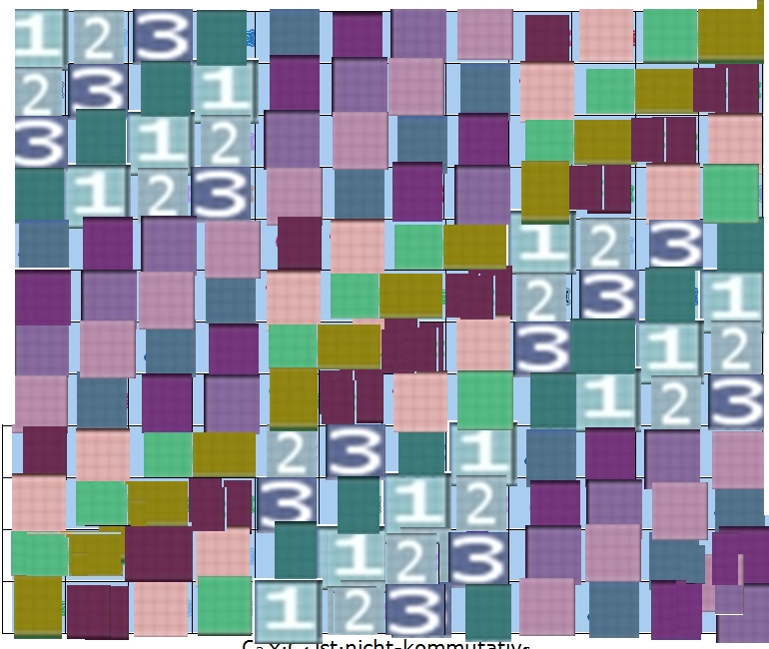
Look at the second diagonal (ocher!)
The structure part I

In the first part we looked at the smallest final goups of numbers. Substituting our rational or real numbers, with witch we are calcuting, this was leading us to the smallest minimal-models of geometry, where the straight lines are consisting of only tw0, three or four points. The whole space of n dimensions has only 2^{n}, 3^{n} or 4^{n} points! These final groups are the elementary particles oft the group theory.

The most importand things we are repeating now!

The smallest group C₂

Since mathematicians like working with numbers, for groups with finitely many elements, we also need finite sets of numbers, because every group operation must stay within the group (associativity is the first group axiom). Remainder classes modulo n yield exactly n residue classes, from 0 to n−1. To distinguish them from ordinary natural numbers one could mark them (e.g. with a “mod n” index). With these, one can form finite groups under addition – and even finite field structures. The smallest field is the residue classes modulo 2 and consists of two parties:

0 ={0, 2, 4, 6, 8, 10, 12, ...…},

where every even number is a representative of the “0” class,
and “1” stands for the class of odd numbers, which leave a remainder when dividing by 2 (namely remainder 1):

1 ={1, 3, 5, 7, 9, 11, 13, ...…}.

But there is also a paradoxical oddity. Because everything is exclusive zero or one, the sum of one and one can not be two, you know.

1 + 1 ≠ 2

One and one is zero

1 + 1 = 0 .

That means, the number one is it´s own inverse element, like 1 = -1
But minus one doesn´t exist, because there are NO NEGATIVE NUMBERS at all!

There was a reader, writing the following to me:
Why should not be 1+1 equal 2? I will not be illuminated by this, because
the modulate class 0 = modulo class 2 (= moduloclass 4 ...)

Dear pupils, is this true? Please write to me: Guruh_can(at)web.de

The second smallest group C₃

{0, 1, 2} has three elements,
Now of course there is 1+1 = 2 again!

 | n | a | b |  |  | + | 0 | 1 | 2
n | n | a | b |  |  | 0 | 0 | 1 | 2
a | a | b | n |  |  | 1 | 1 | 2 | 0
b | b | n | a |  |  | 2 | 2 | 0 | 1
The neutral elements are blue

We can imagine a clock for the groups of oder 12, beginning above with the number 12 o´clock, than turning (by the way mathematically negativ) to the 1 o´clock, than to 2, 3 and so on and finally ending at the beginning at 12,
a cycle C₁₂ wellknown to us all. Now we have a tree-houer a day clock, beginning with zero (equal three) above, followed by one and two and than back above repeating the circle.

We write
(C₃, +) abelian group

For the multiplication, there is ({1, 2}; x) an abelian group too, if you make the zeo-element desapearing eine Gruppe (because it gets no inverses element; it should be infinite 1/0 = ∞ )

PLUS | 0 | 1 | 2
0 | 0 | 1 | 2
1 | 1 | 2 | 0
2 | 2 | 0 | 1
Additionsverknüpfungstafel für C₂
MAL | 1 | 2
1 | 1 | 2
2 | 2 | 1
NOTE:
The muliplication-group never has the zero-Element of the addition!

({0, 1, 2}; +) group or ({0, I, Z}; +, ×) FIELD (commutative).

If we can construct the product of the both smalest groups to C₂ x C₃ or C₃ x C₂ and we are getting in fact an isomorphe group to the cyclic group C_{6.}
But first we talk about the goups with four and five elements.

The two groups with four elements

There exists two abelian versions:
- The cyclic group C₄
plus  mod 4 | 0 | 1 | 2 | 3
0 | 0 | 1 | 2 | 3
1 | 1 | 2 | 3 | 0
2 | 2 | 3 | 0 | 2
3 | 3 | O | 1 | 2
Additiv modulo 4 (has no subgroups!)

The other is due to Felix Klein (1849-1925) teaching at Göttingen since 1886!

- The klein group C₂ x C₂

Every Element is self-invers
In the symmetry group of the rectangle, you can see the 2×2 equality structure
in the main diagonal (“identity”),
and in the other diagonal the same pattern (“without identity”) in the C₂ scheme.
 | 0 degree  = 360 degree  (id) | 180- degree  rotation | reflection um  axis  a | reflection um  axis  b
0 | 0 | 180 | a | b
180 | 180 | 0 | b | a
axis a | a | b | 0 | 180
axis b | b | a | 180 | O

Symmetries of a rectangle.
Structual equalities of 2x2 matix
in the first diagonal `neutrality`
and in the second diagonal equality
The C₂-group yields self‑inverses on the main diagonal
(neutral Element 0 on the first diagonal).
There is a 2‑element subgroup C₂
One after  the other | 0 degree  = 360 (id) | 180-degree rotation
0 | 0 | 180
180 | 180 | 0
C₂ - subgroup of rotations
with 180+180 = 0 degree

NOTE:
In fact 2 times 2 is 4, but this is not true for the groups
The result of C₂ x C₂ is not isomorph to C₄
l C₂ x C₂ ≠ C₄. . l

You must not think, group theory is no object to modern physics like quantum theory. The Pauli-matrix-group is a finite group of order 16 = 2 x 8, that is the (semi-direct) product oft the eight-elementy group of quaternions Q₈
( groups of order eight) and C₂, fundamental in quantum-informations-theory:
Pauli-group = Q₈ x C₂

The so called Pauli-matrixes in quantum physics are the following three 2x2 Matrixes of Wolfgang Pauli (nobel price 1945):
0 1
σ₁ = X = matrix
1 0
0 i
σ₂ = Y = matrix
-i 0
1 0
σ₃ = Z = matrix
0 -1
Together with the unit-matrix (id), you get something like a multiplication group of order 4:

All elements are self-inverse:

σ₁ is a rotation with 180 degrees and doing it tweice is the identity σ₁² = id

σ₂²= 0 i mal 0 i
-i 0 -i 0 is the identity too

σ₃²= 1 0 mal 1 0
0 -1 0 -1 is the identity too

σ₁ σ₂ is i 0 i= iσ₃
0 -i but σ₂ σ₁ -i 0
0 i = - iσ₃
the negativ result
„anti-commutativ!“
_{but not} σ₁

σ₂σ₃ ist 0 -i = iσ₁ and
i 0 exchanged σ₃ mal σ₂ 0 -i
i 0 = - iσ₁

σ₃ σ₁ ist 0 1
-1 0 also -iσ₂ und σ₁ times σ₃ is 0 -1
1 0 = iσ₂

{id, X, Y, Z} is a pseudo-Klein-group

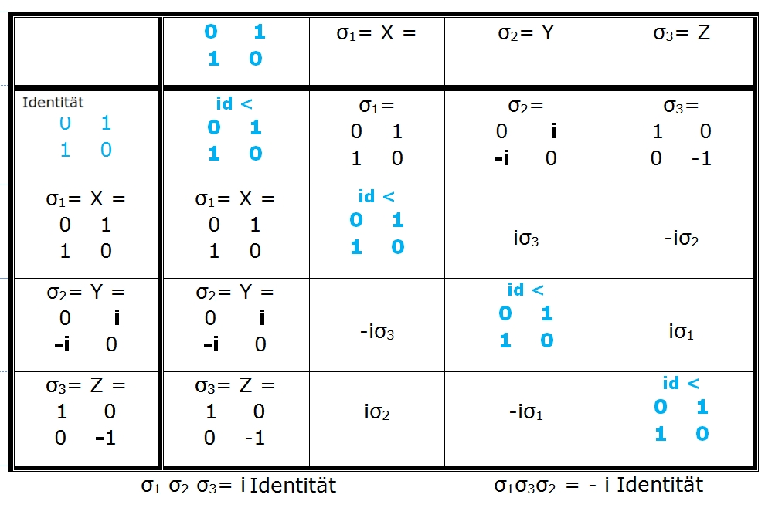Pauli-matrixe table

You could think, that the Modulogroups are no more cyclic relativ to the multiplication, what is always the case relativ to the addition, witch were build up bei the unit-element. However there is the same cyclic structure like the additive (C₄, +) abelian, group (division by 5 without the zero element - cause the multiplicative group always excludes the additive identity element 0)

mal  mod 5 | 1 | 2 | 3 | 4 |  | mal  mod 5 | 1 | 2 | 3 | 4
1 | 1 | 2 | 3 | 4 |  | 1 | 1 | 2 | 3 | 4
2 | 2 | 4 | 1 | 3 |  | 2 | 2 | 4 | 1 | 3
3 | 3 | 1 | 4 | 2 |  | 4 | 4 | 3 | 2 | 1
4 | 4 | 3 | 2 | 1 |  | 3 | 3 | 1 | 4 | 2

The multiplikation group mod 5 has not the neutrale Element 0 of the addition
but is cyclic and therefore abelian too (exchange the 4 and 3)
The multiplication group (right above) is isomorph to C₄ (bottom left)

mal  mod 5 | 1 | 2 | 3 | 4 |  |  |  | mal  mod 5 | 1 | 2 | 4 | 3
1 | 1 | 2 | 3 | 4 |  |  |  | 1 | 1 | 2 | 4 | 3
2 | 2 | 4 | 1 | 3 |  |  |  | 2 | 2 | 4 | 3 | 1
4 | 4 | 3 | 2 | 1 |  |  |  | 4 | 4 | 3 | 1 | 2
3 | 3 | 1 | 4 | 2 |  |  |  | 3 | 3 | 1 | 2 | 4
4 is swapped with 3 and vice versa)

The additive group (mod 4) has 0 and not 1 as neutral element!

Proof of structural equivalence:

For the exponential function 2^x we have
...f(a + b) = f(a) ◦ f(b)…
This is the requirement that an isomorphism preserves the operationsnamely PLUS (+) and TIMES (◦).
We also have an isomorphism between the additive group C₄ and the multiplicative group modulo 5 without zero (which also has 4 elements)!
Here {0, 1, 2, 3} is mapped to {1, 2, 3, 4} via: x ↦ x+1.

f(0) = 1 so 0 1 OK
f(1) = 2 = 2¹ 1 2 OK
f(2) = 4 = 2^2 = 4 mod 5 and thus 2 ↦ 4.
should go to 3
but goes to 4
f(3) = 8 = 2^3 but that is 3 mod 5 3 ↦ 3
should actually go to 4
but is mapped to itself:
You have to swap the 4 above with the 3.
- The group with five elements

Groups of prime order (i.e. with p elements where p is prime) always have a uniquely determined structure. The only possible group structure is commutative and therefore cyclic.
This group of order 5 is a cyclic group, namely C₅.
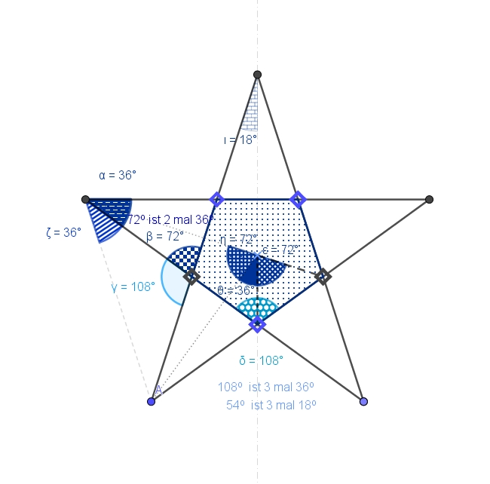
All intersection angles are multiples of 18°,
and the segments are usually divided in the golden ratio.

Of course, the additive group of residue classes modulo 5 is a cyclic group. But one can also rotate the pentagram about its centre by 72° each time to obtain the same cyclic structure of this rotation group!
But the multiplicative group mod 5 – which has only four elements because zero must be excluded – is also a “cyclic” group of order four.

Plus  mod5 | 0 | 1 | 2 | 3 | 4 |  |  | Plus  mod72 | 360º =0º | 72º | 144º | 216º | 288º
0 | 0 | 1 | 2 | 3 | 4 |  |  | 360º=0º | 0º | 72º | 144º | 216º | 288º
1 | 1 | 2 | 3 | 4 | 0 |  |  | 72 º | 72º | 144º | 216º | 288º | 360º
2 | 2 | 3 | 4 | 0 | 1 |  |  | 144º | 144º | 216º | 288º | 360º | 72º
3 | 3 | 4 | 0 | 1 | 2 |  |  | 216º | 216º | 288º | 360º | 72º | 144º
4 | 4 | 0 | 1 | 2 | 3 |  |  | 288º | 288º | 360º | 72º | 144º | 216º
These two groups have the same cyclic structure (they are isomorphic!).

Since 5 is prime, the residue classes mod 5 form a commutative field.

So for groups with 5 elements there is only the cyclic structure C₅!

Thus C₅ forms a commutative group under addition,
and also a commutative group under multiplication,

together with the distributive law (a+b)c = ac + bc,

this gives the structure of a number field;
in short: (C5, +, ◦) is a commutative field.

And this holds not only for groups of order 5, but also for groups of order 7 or 11 and, in fact, for all (Cp, +, ◦) with prime p. These p‑groups are always cyclic and commutative (abelian)!

Two groups with six elements

Exactly how you can build the number 6 out off the factor two and three in two different ways,
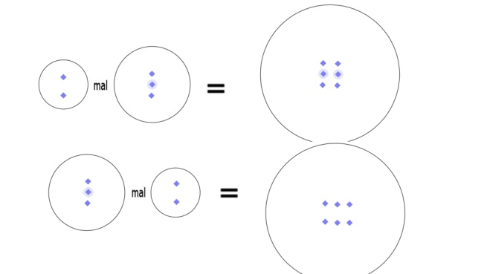
Both have the same result (are equal!)

you can construct the product of the two groups C₂ and C₃ in two different ways as a group C₃ x C₂ or as C₂ x C₃
The group product is not nessesarily abelian! Remember that C₂ x C₂ is not isomorphic to the cyclic groupC₄ ! Pay attension!

But here for the oder six it is, and both products C₂ x C₃ ≡ C₃ x C₂ are isomorph to C₆.

For C₃ x C₂ we look at the cycic group C₃ and substitute each element by a kind of a cyClic Group C_{2.} Where the neutral element zero stands, we get because of adding with zero exactly the cyclic group C₂ unchanged.
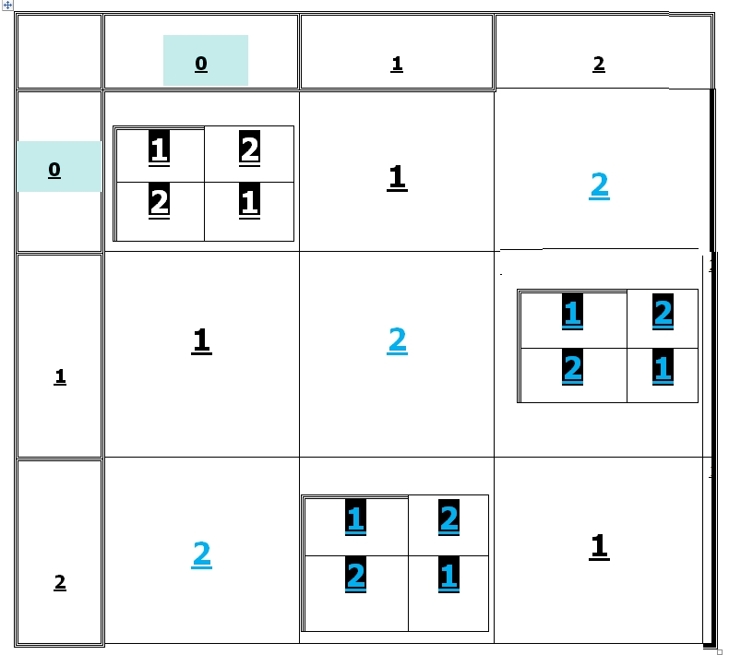
In C₃ x C₂ the elements of the stucture of C₃
are substituted by the group-scheme of a kind of C₂

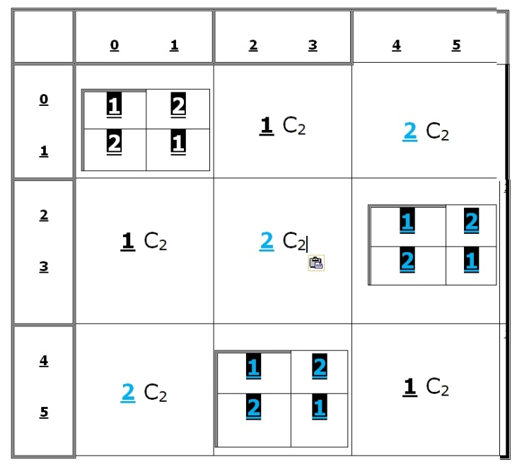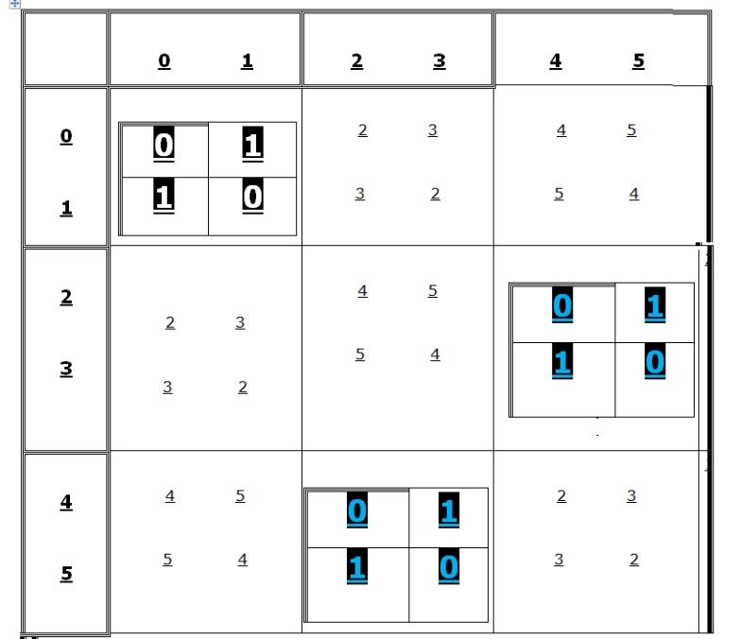
The 1-elemt of C₃ contains now two and three
and we need 4 and 5 too the 2-element

C₃ nach C₂ | 0 | 1 | 2 | 3 | 4 | 5
0 | 0 | 1 | 2 | 3 | 4 | 5
1 | 1 | 0 | 3 | 2 | 5 | 4
2 | 2 | 3 | 4 | 5 | 0 | 1
3 | 3 | 2 | 5 | 4 | 1 | 0
4 | 4 | 5 | 0 | 1 | 2 | 3
5 | 4 | 5 | 1 | 0 | 3 | 2

Set into C₃ for each element the C₂ versions to get C₃ x C₂
Look at the diagonal made of 5-

Otherwise fort the product C₂ x C₃
set C₃ in alll four elements of C₂ d
you get two times two equal kinds of C₃-cheme
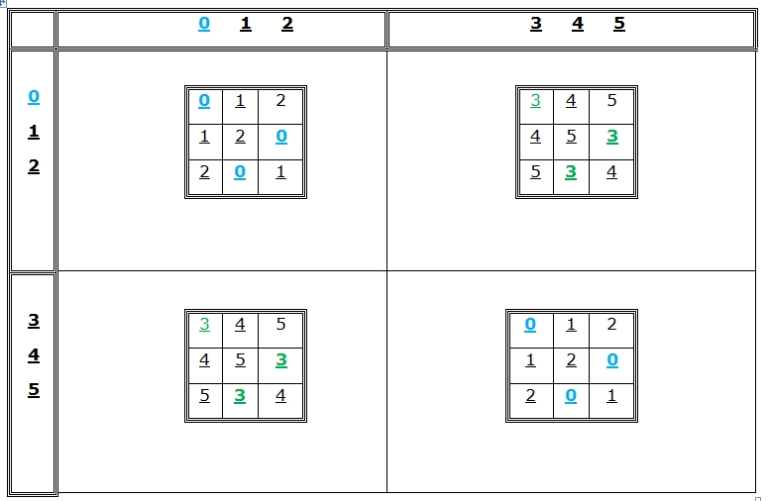
Wenn wir die vier Elemente der C₂ Gruppe durch C₃ –Gruppen ersetzen, entsteht dieses!

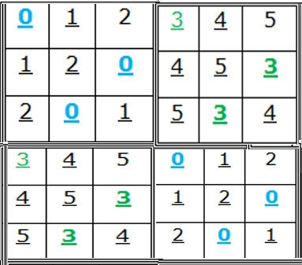
C₂ x C₃

comparison
0 | 1 | 2 | 3 | 4 | 5
1 | 0 | 3 | 2 | 5 | 4
2 | 3 | 4 | 5 | 0 | 1
3 | 2 | 5 | 4 | 1 | 0
4 | 5 | 0 | 1 | 2 | 3
5 | 4 | 1 | 0 | 3 | 2

The typical diagonal of 5 and symmetry to the main-diagonal
means that both are abelien
Both are isomorph the cyclic C₆

There exist only two structures for groups with 6 elements:
an abelian C₆
and
a not-abelian
That ist the rotation and axis -ysmmetries of the equilateral triangle D₃
(with is isomorph to the group S₃ of permutations for three elements ).

 | 0 | 1 | 2 | 3 | 4 | 5
0 | 0 | 1 | 2 | 3 | 4 | 5
1 | 1 | 2 | 0 | 4 | 5 | 3
2 | 2 | 0 | 1 | 5 | 3 | 4
3 | 3 | 4 | 5 | 0 | 1 | 2
4 | 4 | 5 | 3 | 1 | 2 | 0
5 | 5 | 3 | 4 | 2 | 0 | 2

C₃ x C₂ ≡ C ₆
≡C₆ | 0 | 4 | 2 | 3 | 1 | 5
0 | 0 | 4 | 2 | 3 | 1 | 5
4 | 4 | 2 | 3 | 1 | 5 | 0
2 | 2 | 3 | 1 | 5 | 0 | 4
3 | 3 | 1 | 5 | 0 | 4 | 2
1 | 1 | 5 | 0 | 4 | 2 | 3
5 | 5 | 0 | 4 | 2 | 3 | 1

Exchanging 1 with 4
(the neutral element is blue)

Likewise, the non‑zero residue classes modulo the prime 7 form a group with six elements, since the (additive) zero must be excluded. Both groups have the same (cyclic) structure, as one can see by swapping some elements. There is, however, another group structure of order six, namely S₃ – and it is neither commutative nor even cyclic !

a times b | 1 | 2 | 3 | 4 | 5 | 6 |  |  |  | 1 | 3 | 2 | 6 | 4 | 5
1 | 1 | 2 | 3 | 4 | 5 | 6 |  |  | 1 | 1 | 3 | 2 | 6 | 4 | 5
2 | 2 | 4 | 6 | 1 | 3 | 5 |  |  | 3 | 3 | 2 | 6 | 4 | 5 | 1
3 | 4 | 1 | 5 | 2 | 6 | 3 |  |  | 2 | 2 | 6 | 4 | 5 | 1 | 3
4 | 3 | 6 | 2 | 5 | 1 | 4 |  |  | 6 | 6 | 4 | 5 | 1 | 3 | 2
5 | 5 | 3 | 1 | 6 | 4 | 2 |  |  | 4 | 4 | 5 | 1 | 3 | 2 | 6
6 | 6 | 5 | 4 | 3 | 2 | 1 |  |  | 5 | 5 | 1 | 3 | 2 | 6 | 4
The multiplicative group of residue classes mod 7
i.e. with respect to divisibility by seven (left) is
structurally identical (isomorphic) to the cyclic group C₆ (right).

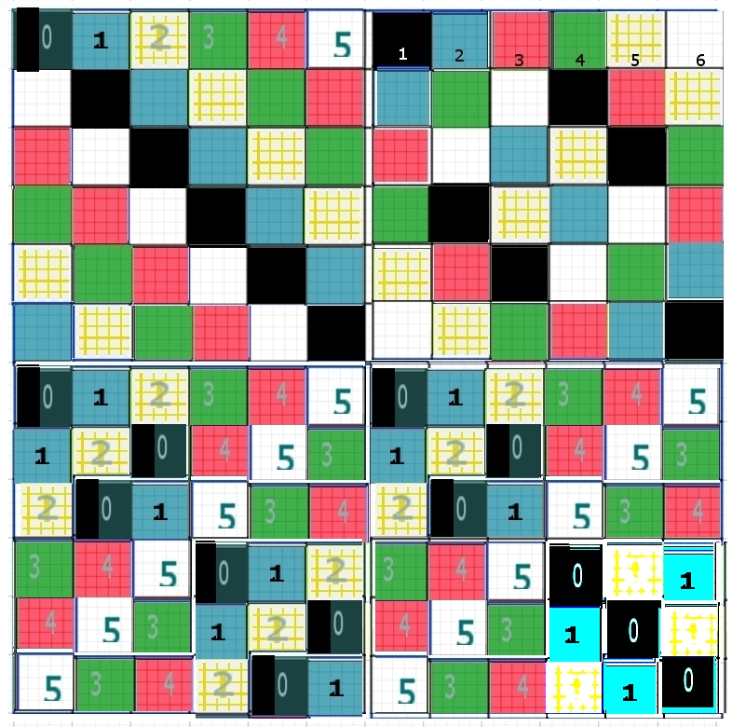
With group is not abelian?
Only the last!
At the bottom to the very right end there is a group no structure of C₃
(three zeros in the main diagonal)

All groups up to order six are commutative, i.e. combining a with b yields the same value when a and b are swapped; the Cayley table is therefore symmetric about the main diagonal. In particular, all finite fields are commutative: in addition and multiplication one may swap summands or factors.

The non-abelian group with six elements

The reality is not exactly mirror image symmetric, U know!
Noboy really understands for example, why there is only matter and no anti-matter in the univers.

The non-abelian symmetric groups S_{n} and such like the the symmetries of a reg. n-polygon (dihedral groups D_{n}) or the alternating groups A_{n} are importend.
The refections and rotations dont communicate.
Wener Heisenberg noticed in quantum physics, the it matters, if you measure first the velocity of a particle and than the location or vis versa detect first his location (coordinnate x) and than it ´s impuls p = m*v (that means the vilocity v)
This was leading to the well-know uncertainty-relation with the Planck-constant h
(and further to the elementary length of PLANCK 10⁻³⁵ m)
:

Δx * Δp > h
You cannot measure the exact position and velocity of any particle at the same time
Non-abelian groups are importand for elementary particel-physics !

The first non‑commutative group
is the permutation group on 3 elements,
with 3! = six permutations,
also known as the symmetric group S₃.

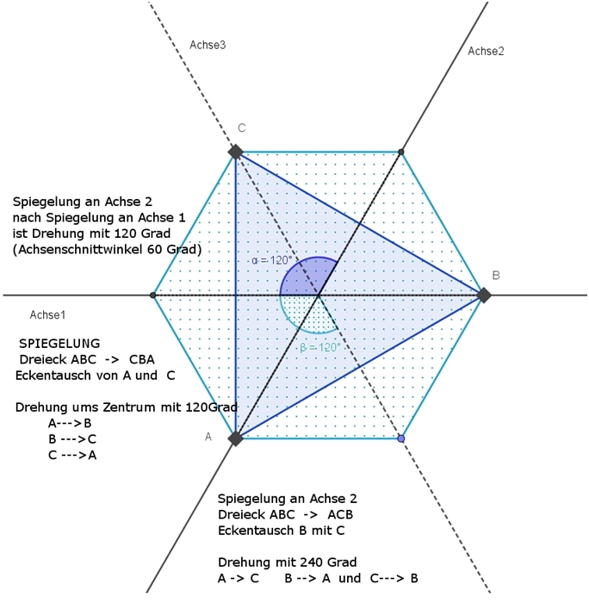

The first non‑commutative group has order 6.
The triangle has 6 congruence transformations,
which form the non‑commutative group D₃

Triangle-symmetries | 0◦ | 120◦ | 240◦ | a | b | c
0◦ | 0◦ | 120◦ | 240◦ | a | b | c
120◦ | 120◦ | 240◦ | 0◦ | b | c | a
240◦ | 240◦ | 0◦ | 120◦ | c | a | b
a | a | b | c | 0◦ | 240◦ | 120◦
b | b | c | a | 120◦ | 0◦ | 240◦
c | c | a | b | 240◦ | 120◦ | 0◦
Rotations 0, 120 and 240 degrees and reflections at the axis a, b and c
D₃ and S₃ are isomorphic

Dreh-UG | 0◦ | 120◦ | 240◦
0◦ | 0◦ | 120◦ | 240◦
120◦ | 120◦ | 240◦ | 0◦
240◦ | 240◦ | 0◦ | 120◦
The rotations build a abbelian subgroup C₃

It is isomorphic to the dihedral group D₃ of the regular triangle and also isomorphic to the “general linear” group GL2(2) of 2×2 matrices, which are invertable.

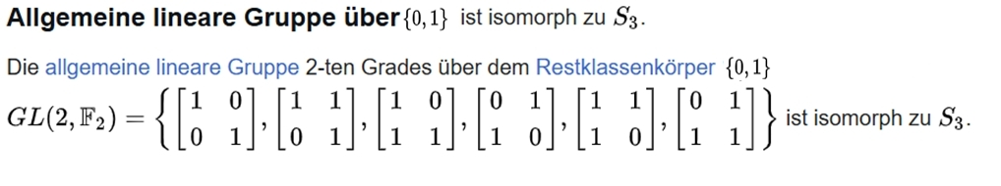
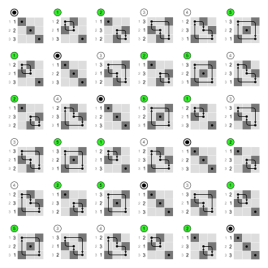
Cayley-Table od the symmetric group S₃
with pemutations in matrix-form
www.math.uni-konstanz.de/~kuhlmann/Lehre/SS12-LinAlg2/Skripts/07-LinAlg2-120507.pdf

It is well known, a set consisting of n elements has n! permutations. For example, there are 3! = 1×2×3 = 6 ways to rearrange the letters of the word “MIT”.

The six permutations of a 3‑element set are:
id = (11; 22; 33) identische Abbildung (= neutrales Element)
1 = (11; 23; 32) only 2 and 3 are swapped (self‑inverse)
2 = (13; 22; 31) only 1 and 3 are swapped (self‑inverse)
3 = (12; 21; 33) only 2 and 1 are swapped (self‑inverse)
4 = (12; 23; 31)
5 = (13; 21; 32)

We have 1 ◌ 2 = 5 (“◌” means composition in sequence, e.g. of maps that need not commute), but 2 ◌ 1 = 4.
2 ◌ 1 bedeutet 1nach 3 nach 2, 2 nach 2 nach 3, 3 nach 1 nach 1:
123- 231 = 4
4 ◌ 4 = 5 and 5 ◌ 5 = 4.

What is the inverse map of 5 = (13; 21; 32)?
It is (12; 23; 31), so 4 ◌ 5 = id = 5 ◌ 4.

Every permutation is a product of transpositions (swaps)!
Example: 3-cycle
(1, 7, 6) = (1 versus 7) (7 versus 6) -
and (2, 5, 3) into the 2‑cycles (2 with 5) (5 with 3).
This group contains four subgroups: three 2‑element subgroups
(with the self‑inverses 1, 2 or 3) and one 3‑element subgroup {n, 4, 5}, which is even a normal subgroup.

permuting 3 elements | id | 4 | 5 | (2 3) | (1 3) | (1 2)
id | id | 4 | 5 | (2 3) | (1 3) | (1 2)
4 | 4 | 5 | id | (1 2) | (2 3) | (1 3)
5 | 5 | id | 4 | (1 3) | (1 2) | (2 3)
(2 3) | (2 3) | (1 3) | (1 2) | id | 5 | 4
(1 3) | (1 2) | (2 3) | (1 3) | 4 | id | 5
(1 2) | (1 3) | (1 2) | (2 3) | 5 | 4 | id

Non-abelian S₃ ≡ D₃

By Lagrange’s theorem, the order of any subgroup of a finite group always divides the order of the group. Therefore, in order 6 there can only be subgroups of order 2 or 3.

Since permutations capture all possible rearrangements, every finite group is a subgroup of a permutation group, whose general structure is, however, complicated: every finite group G is isomorphic to a subgroup of the symmetric group S_{n}, and the subgroup order divides the order of S_{n} (Cayley’s theorem). But not to every divisor of the group-order n exists always a subgroup. For example A₄ has 12 Elements, but no subgroup of order 6.
All finite groups are reflected within the symmetric groups S_{n} as well.

“Group theory” is the study of symmetries (= permutations)!

S_{n} the symmetric group of degree n is defined as the group of permutations of n elements. A permutation can be decomposed into an even or an odd number of transpositions (2‑cycles, 3‑cycles, …). A_{n} the alternating group of even permutations is of particular interest, as it provides the first series of so‑called simple groups (= having no normal subgroups).
The A₅ is the rotation group of the reg. icosaeder (and to the dual dodecaeder).
As half of S₅ there are 60 elements, cause 5! = 4 times 24 = 120.
A₅ is the smallest simple group and the smallest non-solvable!
Simple groups and “unsolvable” groups are closely related; the latter are in demand in Galois theory as Galois groups of polynomials of degree n. The splitting field of an irreducible polynomial of degree 5, for example x^5 − 4x + 2, is not solvable by radicals: there can be no general solution formula for the roots of degree‑5 polynomials that is based only on successive radical expressions in the coefficients.
A more easier proof with A₅ uses Sylow: Look to the bibel of group theory, the textbook of B. Huppert: Endliche Gruppen I, Springer-Verlag, 1967

With non‑commutative groups the real problems begin. Fortunately, left identity is still the same as right identity, but forming products of groups is no longer so straightforward (especially when they are not commutative). In any case, subgroups are generally no longer “normal”, whereas in commutative groups they always are – namely normal subgroups (normal divisors). Normal subgroups are used for what is now called the semidirect product!

Normal subgroups of G are those subgroups U for which
the left cosets are also the right cosets:
gU = Ug for all g in the group G

Equivalently, under conjugation, for all g in G and x in U we have g x g⁻¹ again in the subgroup; or (gN)(hN) = ghN for all g and h in G.

In commutative groups – as already said – all subgroups are always normal. Furthermore, every 2‑element subgroup ≡ C₂ is always normal (what is very important for classification).
For structural investigations, the kernel of a group homomorphism is particularly important; it consists of the subgroup of all elements mapped to the identity. The kernels of homomorphisms are precisely the normal subgroups. As an example, consider the kernel of the general linear maps GL_{n}(R), represented by n×n matrices from R^n to R^n with non‑zero determinant. The kernel of this general linear group
is Ker GLn(R) = SL_{n}(R) the special linear group
These are those with determinant det = 1, SL_{n}(R), i.e. the non‑degenerate homogeneous, area‑preserving congruence transformations.
If a group has no normal subgroup (other than the identity element), then it has prime order and is called simple. Thus, all cyclic groups C_{p} are simple.
The alternating group A₅ is the smallest non‑commutative simple group, and it is isomorphic to every simple group of order 60.

Reminder: every permutation can be represented as a product of transpositions (2‑cycles). Depending on whether this number is even or odd, one speaks of even or odd permutations. The set of even permutations forms a subgroup of S_{n} with half the size of elements: the alternating group A_{n}. A_{n} is a normal subgroup of S_{n}!
Example: A₄ is a group of order 12, i.e. it has 12 elements and half the number of elements of S₄ (4! = 24 permutations). A₄ is a normal subgroup of S₄ (but it has no subgroup of order 6).

A₅ is a group of order 60, i.e. it has half as many elements as S₅ (5! = 5×4! = 120).
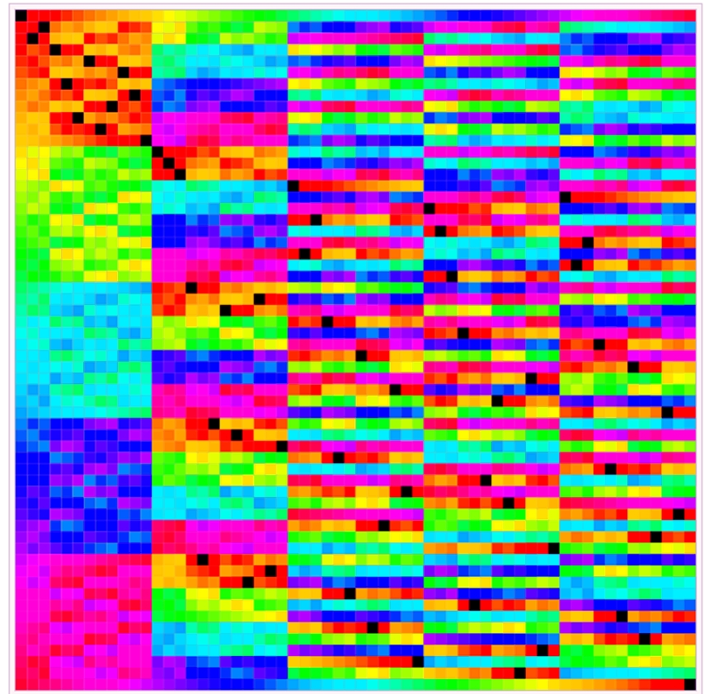
The smallest non-abelian simple group A₅
Alternating group A₅ with 60 elementa
You can clearly see the 5 times 5 blocks of 12x12 elements
The neutal elements are black

The fundamental building blocks of group theory are the finite “simple” groups. The complete classification of the simple groups – on which several hundred mathematicians worked intensively for over 30 years – was completed in 1981. Some proofs, virtually unparalleled within mathematics, were published in about 500 articles totalling over 15,000 pages. The classification theorem clarifies one result: the simple commutative groups are exactly the groups of prime order, and the simplest non‑commutative simple groups are the alternating groups.
However, since symmetric groups have a very difficult structure, people began searching for other types of groups that are easier to handle, and whose isomorphisms nevertheless allow conclusions about the structure of normal groups. The general linear groups GL_{n}(R) proved particularly suitable. The mathematics of matrices concerned with the study of such linear representations is called representation theory.

Groups with eight elements

Three abelian and two non-abelian

Overview of the 5 different structures of order eight:

Among the five different group structures of order eight, the following
three are commutative:
the cyclic C₈,
as well as C₄ × C₂,
and C₂ × C₂ × C₂
in which every element is its own inverse.

And the two non‑commutative groups are
D₄ and Q₈
very similar dihedral groups for n = 4:
and the quaternion group Q₈.
The quaternion group Q₈ has the eight elements {±1, ±i, ±j, ±k},
and it is well known that the squares of i, j and k, as well as ijk, equals −1.

The dihedral groups D_{n} are the symmetry groups of the regular n‑gons. They consist of n rotations about the centre and n reflections about the perpendicular bisectors and diagonals that map the n‑gon onto itself.
The symmetry group of the square D₄ has order eight and, like all D_{n}, is non‑commutative.

For the octagon these are the rotations by 0 up to 7 times the angle (360°/8 =) 45°. D₈ is the non‑commutative symmetry group of the regular octagon with 16 elements:

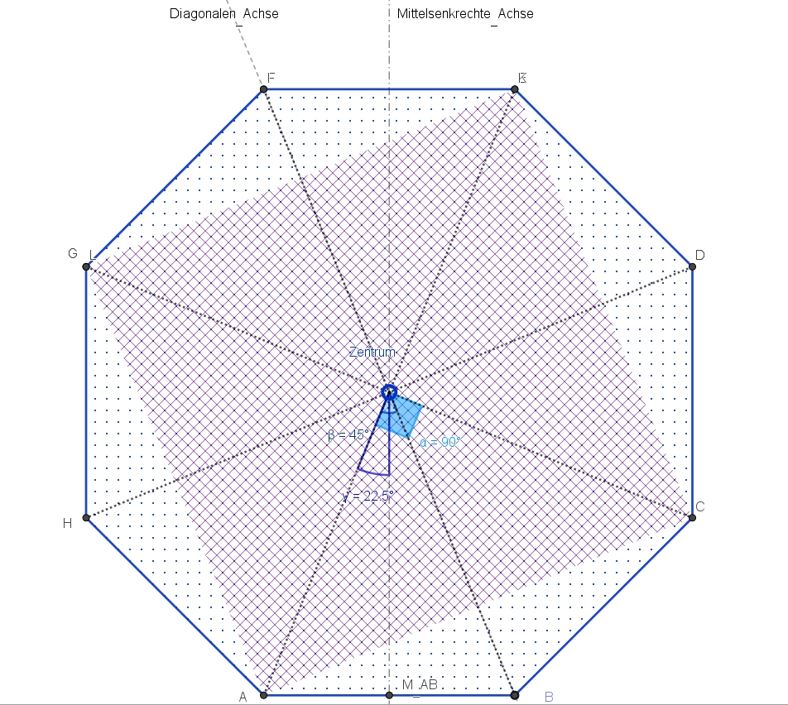

The eight rotations by multiples of 360°/8 = 45° form a cyclic group with the structure of C8. The eight reflections, however, do not form a group, because two reflections always yield a rotation about the intersection point of the axes (= centre of rotation) by twice the angle between the axes. Together, however, they form a non‑commutative dihedral group with 16 elements.
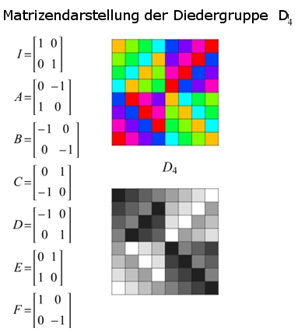
D₄ with matrixes
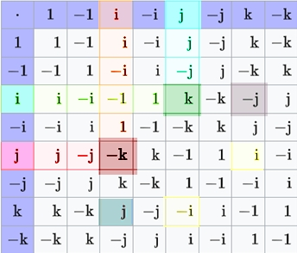
Quaternion group Q₈
The (hamilton) quaternion group Q8 has eight elements {±1, ±i, ±j, ±k},
with connection Q₈ x Q₈ → Q₈
with the squares of i, j and k equal -1 like ijk.
The produchts of different imaginäry units
are anti-commmutativ,
like ik = -ki

All subgroups of Q₈ are normal; there are three maximal C₂ x C₂-subgroups. As a subgroup oft he general linear group GL₂(C)) you can write the imaginary units as matrixes
i =
√-1 0
0 -√-1

j =
0 1
-1 0

k =
0 √-1

√-1 0

Let us turn to one of the three commutative groups of order eight, the cyclic C₈:
As translations, in the spatial minimal model ({0,1})³ we have the following 2³ = 8 spatial vectors available, with only two digits:
(0, 0, 0), (1, 0, 0), (0, 1, 0), (0, 0, 1), (1, 1, 0), (0, 1, 1), (1, 0, 1), and (1, 1, 1).
Two translations naturally yield another translation (corresponding to adding the two displacement vectors), and these form a commutative group.

 | in  sequence | (0,0,0) | (1,0,0) | (0,1,0) | (1,1,0) | (0,0,1) | (1,0,1) | (0,1,1) | (1,1,1)
 | (0, 0,0) | (0,0,0) | (1,0,0) | (0,1,0) | (1,1,0) | (0,0,1) | (1,0,1) | (0,1,1) | (1,1,1)
 | (1, 0,0) | (1,0,0) | (0,0,0) | (1,1,0) | (0,1,0) | (1,0,1) | (0,0,1) | (1,1,1) | (0,1,1)
 | (0, 1,0) | (0,1,0) | (1,1,0) | (0,0,0) | (1,0,0) | (0,1,1) | (1,1,1) | (0,0,1) | (1,0,1)
 | (1, 1,0) | (1,1,0) | (0,1,0) | (1,0,0) | (0,0,0) | (1,1,1) | (0,1,1) | (1,0,1) | (0,0,1)
 | (0,0,1) | (0,0,1) | (1,0,1) | (0,1,1) | (1,1,1) | (0,0,0) | (1,0,0) | (0,1,0) | (1,1,0)
 | (1,0, 1) | (1,0,1) | (0,0,1) | (1,1,1) | (0,1,1) | (1,0,0) | (0,0,0) | (1,1,0) | (0,1,0)
 | (0,1, 1) | (0,1,1) | (1,1,1) | (0,0,1) | (1,0,1) | (0,1,0) | (1,1,0) | (0,0,0) | (1,0,0)
 | (1,1, 1) | (1,1,1) | (0,1,1) | (1,0,1) | (0,0,1) | (1,1,0) | (0,1,0) | (1,0,0) | (0,0,0)
The commutative group of order eight C₈ of translation vectors
of {0,1}³, the smallest possible Euclidean space!
C₂ × C₂ × C₂

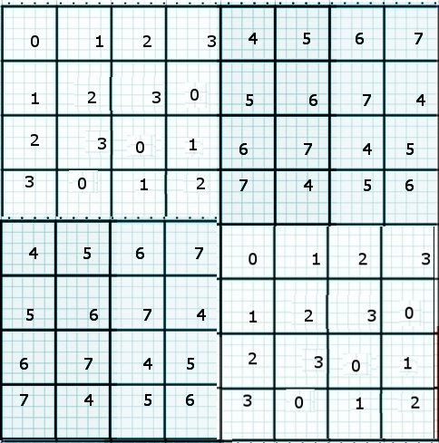
C₄ X C₂ is not isomorphic to zu C₈
0 | 1 | 2 | 3 | 4 | 5 | 6 | 7
1 | 0 | 3 | 2 | 5 | 4 | 7 | 6
2 | 3 | 4 | 5 | 6 | 7 | 0 | 1
3 | 2 | 5 | 4 | 7 | 6 | 1 | 0
4 | 5 | 6 | 7 | 0 | 1 | 2 | 3
5 | 4 | 7 | 6 | 1 | 0 | 3 | 2
6 | 7 | 0 | 1 | 2 | 3 | 4 | 5
7 | 6 | 1 | 0 | 3 | 2 | 5 | 4

C₄ X C₂ ist abelian too
(the semi-direct product C₄ |X C₂ ≡ D₄ is non-abelian)

Two abelian groups
with nine elements

First the cyclic C₉

plus- | 0 | 1 | 2 | 3 | 4 | 5 | 6 | 7 | 8
0 | 0 | 1 | 2 | 3 | 4 | 5 | 6 | 7 | 8
1 | 1 | 2 | 3 | 4 | 5 | 6 | 7 | 8 | 0
2 | 2 | 3 | 4 | 5 | 6 | 7 | 8 | 0 | 1
3 | 3 | 4 | 5 | 6 | 7 | 8 | 0 | 1 | 2
4 | 4 | 5 | 6 | 7 | 8 | 0 | 1 | 2 | 3
5 | 5 | 6 | 7 | 8 | 0 | 1 | 2 | 3 | 4
6 | 6 | 7 | 8 | 0 | 1 | 2 | 3 | 4 | 5
7 | 7 | 8 | 0 | 1 | 2 | 3 | 4 | 5 | 6
8 | 8 | 0 | 1 | 2 | 3 | 4 | 5 | 6 | 7
C₉
 | 0 | I | Z | 3 | 4 | 5 | 6 | 7 | 8
0 | 0 | I | Z | 3 | 4 | 5 | 6 | 7 | 8
I | I | Z | 0 | 3I | 4I | 5I | I Z | Z Z | 8 Z
Z | Z | 0 | I | 3Z | 4Z | 5Z | Z Z | 7 Z | I Z
3 | 3 | 3I | 3Z | 3 Z | I Z | Z Z | 0 | I | Z
4 | 4 | 4I | 4Z | I Z | Z Z | 5 Z | I | Z | 0
5 | 5 | 5I | 5Z | Z Z | 4 Z | I Z | Z | 0 | I
6 | 6 | 6 Z | Z Z | 0 | I | Z | 0 I | I I | Z I
7 | 7 | Z Z | 7 Z | I | Z | 0 | I I | Z I | 0 I
8 | 8 | 8 Z | I Z | Z | 0 | I | Z I | 0 I | I I
C₃ x C₃
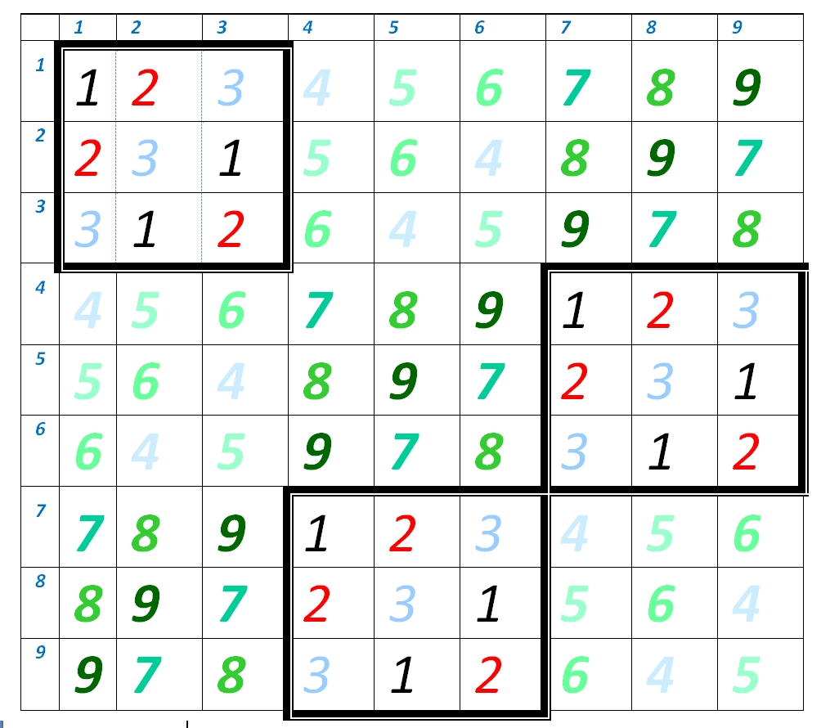
C₃ x C₃

We look at the translations in the second smallest two dimensional euklidean minimalmodell
{0, 1, 2}²
There exists nine translations, but only four have different directionn
1, 0), (0,1), (1,1) und (1,2) || (2,1). For that reason pass exactly four lines through every point!
.

nach-  einander | (0,0) | (1,0) | (0,1) | (1,1) | (1,2) | (2,0) | (0,2) | (2,1) | (2,2)
(0, 0) | (0,0) | (1,0) | (0,1) | (1,1) | (1,2) | (2,0) | (0,2) | (2,1) | (2,2)
(1, 0) | (1,0) | (2,0) | (1,1) | (2,1) | (2,2) | (0,0) | (1,2) | (0,1) | (0,2)
(0, 1) | (0,1) | (1,1) | (0,2) | (1,2) | (1,0) | (2,1) | (0,0) | (2,2) | (2, 0)
(1, 1) | (1,1) | (2,1) | (1,2) | (2,2) | (2,0) | (0,1) | (1,0) | (0,2) | (0,0)
(1, 2) | (1,2) | (2,2) | (1,0) | (2,0) | (2,1) | (0,2) | (1,1) | (0,0) | (0,1)
(2, 0) | (2,0) | (0,0) | (2,1) | (0,1) | (0,2) | (1,0) | (2,2) | (1,1) | (1,2)
(ß, 2) | (0,2) | (1,2) | (0,0) | (1,0) | (1,1) | (2,2) | (0,1) | (2,0) | (2,1)
(2, 1) | (0,2) | (0,1) | (2,2) | (0,2) | (0,0) | (1,1) | (2,0) | (1,2) | (1,0)
(2, 2) | (2,2) | (0,2) | (2,0) | (0,0) | (0,1) | (1,2) | (2,1) | (1,0) | (1,1)
The abelian group oft he directions (translations) of {0, 1, 2}²
because 3² = 9 of order niner (symmetrie to main diagonal axis)
isomorphly to C₃ x C₃

C₃ x C₃ ≠ C₉

There are two different structures of abelian groups with order nine (like groups of order four)!

Two groups with ten elements

an abelian and a non-abelian

these are of course the cyclic C₁₀ ≡ C₂ x C₅ and the non-abelian D5 with the 10 symmetries of the reg. pentagon ( 5 refections and 5 rotations)
D₅ ≡ C₅ x C₂.

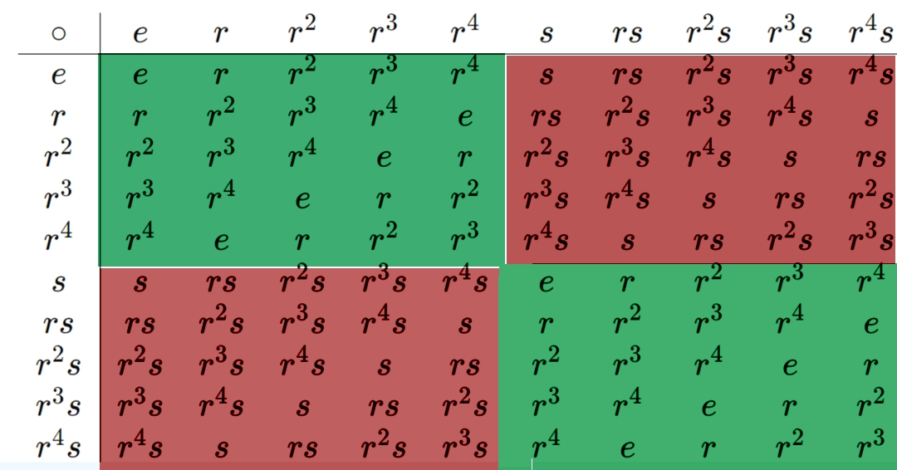
Cayley-table for D₅

The dihedral groupe D_{n} is sometimes written as D_{2n} too.
D₆ (or D₁₂) are the symmetries of the hexagon (coming now).

With eleven elements ther is only one structure again, to say C₁₁ ,
cause 11 is prim!
.

Five groups
with twelve elements

The two abelian groups are
C₁₂ ≅ C₄×C₃
C₂×C₆ ≅ C₂×C₂×C₃ ≅ D₂×C₃

and the tree non-abelian are
D₆, A₄ and the di-cyclic group dic₃

1 | 2 | 3 | 4 | .5 | 6 | 7 | 8 | 9 | 10 | 11 | 12
2 | 3 | 4 | .5 | 6 | 7 | 8 | 9 | 10 | 11 | 12 | 1
3 | 4 | .5 | 6 | 7 | 8 | 9 | 10 | 11 | 12 | 1 | 2
4 | .5 | 6 | 7 | 8 | 9 | 10 | 11 | 12 | 1 | 2 | 3
.5 | 6 | 7 | 8 | 9 | 10 | 11 | 12 | 1 | 2 | 3 | 4
6 | 7 | 8 | 9 | 10 | 11 | 12 | 1 | 2 | 3 | 4 | .5
7 | 8 | 9 | 10 | 11 | 12 | 1 | 2 | 3 | 4 | .5 | 6
8 | 9 | 10 | 11 | 12 | 1 | 2 | 3 | 4 | .5 | 6 | 7
9 | 10 | 11 | 12 | 1 | 2 | 3 | 4 | .5 | 6 | 7 | 8
10 | 11 | 12 | 1 | 2 | 3 | 4 | .5 | 6 | 7 | 8 | 9
11 | 12 | 1 | 2 | 3 | 4 | .5 | 6 | 7 | 8 | 9 | 10
12 | 1 | 2 | 3 | 4 | .5 | 6 | 7 | 8 | 9 | 10 | 11
Cyclic C₁₂
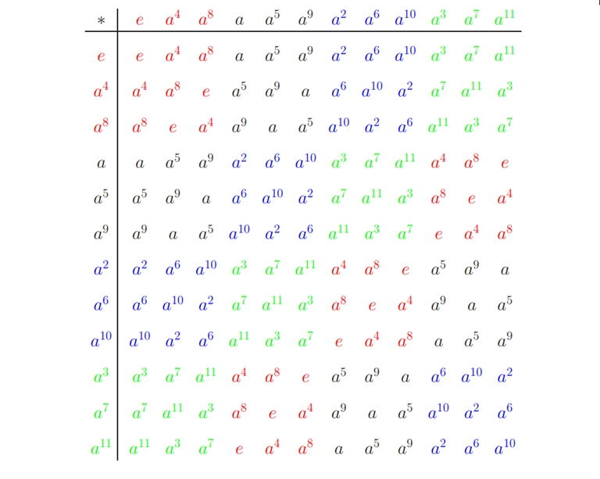
https://tu-dresden.de/mn/math/algebra/das-institut/beschaeftigte/antje-noack/ressourcen/dateien/v-120-2/MathMethInf04Zusatz.pdf?lang=de
C₁₂ is isomorphly to C₄ x C₃
All subgroups of C₁₂ are cyclic andnormal!
You see the coloured sixteen 3-blocks
The one consisting of 4-blocks C₃×C₄ is nevertheless non-abelian!

The three abelian grups can be determind without using Sylow – groups directly:
For the 3-sylow-groupther is C₃ the only one possibility
and for the 2-sylow-groups either C₄ or C₂xC₂
www.matheboard.de/archive/390196/thread.html

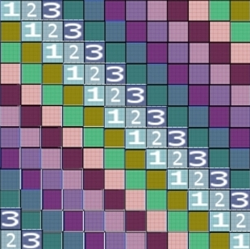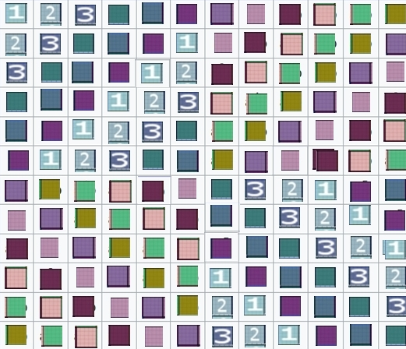
Comparison abelian (left) and non-abelian (on the right)

The tree non-abelian 12-groups
D₆ the dihedral group of order 12 is actually the group of symmetries of a regular hexagon. There are two generators of this group, the rotation through 60 degrees (r) and the flip where the hexagon is flipped round to the back (s). By combining these two movements, the 12 symmetries can be effected.
Under the further lift through the spin group-double cover map $SU(2)≃Spin(3)→SO(3)$ of the special orthogonal group, the dihedral group $D_{2n}$ is covered by the binary dihedral group, also known as the dicyclic group and denoted
$$2D_{2n}={Dic}_{n}$$
https://ncatlab.org/nlab/show/dihedral+group

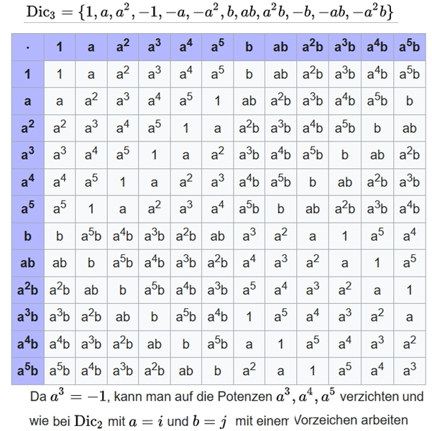
The dicyklische Gruppe Dic₂ is isomorphly to quaternion group Q₈
a = ½(1+i√3) und b = j (to avoid the negativ signs)
The non-abelian Dic₃

Die Gruppe mit fünfzehn Elementen

1 | 2 | 3 | 4 | .5 | 6 | 7 | 8 | 9 | 10 | 11 | 12 | 13 | 14. | 15.
2 | 3 | 4 | .5 | 6 | 7 | 8 | 9 | 10 | 11 | 12 | 13 | 14. | 15. | 1
3 | 4 | .5 | 6 | 7 | 8 | 9 | 10 | 11 | 12 | 13 | 14. | 15. | 1 | 2
4 | .5 | 6 | 7 | 8 | 9 | 10 | 11 | 12 | 13 | 14. | 15. | 1 | 2 | 3
.5 | 6 | 7 | 8 | 9 | 10 | 11 | 12 | 13 | 14. | 15. | 1 | 2 | 3 | 4
6 | 7 | 8 | 9 | 10 | 11 | 12 | 13 | 14. | 15. | 1 | 2 | 3 | 4 | .5
7 | 8 | 9 | 10 | 11 | 12 | 13 | 14. | 15. | 1 | 2 | 3 | 4 | .5 | 6
8 | 9 | 10 | 11 | 12 | 13 | 14. | 15. | 1 | 2 | 3 | 4 | .5 | 6 | 7
9 | 10 | 11 | 12 | 13 | 14. | 15. | 1 | 2 | 3 | 4 | .5 | 6 | 7 | 8
10 | 11 | 12 | 13 | 14. | 15. | 1 | 2 | 3 | 4 | .5 | 6 | 7 | 8 | 9
11 | 12 | 13 | 14. | 15. | 1 | 2 | 3 | 4 | .5 | 6 | 7 | 8 | 9 | 10
12 | 13 | 14. | 15. | 1 | 2 | 3 | 4 | .5 | 6 | 7 | 8 | 9 | 10 | 11
13 | 14. | 15. | 1 | 2 | 3 | 4 | .5 | 6 | 7 | 8 | 9 | 10 | 11 | 12
14. | 15. | 1 | 2 | 3 | 4 | .5 | 6 | 7 | 8 | 9 | 10 | 11 | 12 | 13
15. | 1 | 2 | 3 | 4 | .5 | 6 | 7 | 8 | 9 | 10 | 11 | 12 | 13 | 14.

C₁₅

1 | 2 | 3 | 4 | .5 | 6 | 7 | 8 | 9 | 11 | 12 | 13 | 13 | 14. | 15.
2 | 3 | 1 | .5 | 6 | 7 | 8 | 9 | 10 | 12 | 13 | 14. | 14. | 15. | 1
3 | 1 | 2 | 6 | 7 | 8 | 9 | 10 | 11 | 13 | 14. | 15. | 15. | 1 | 2
4 | .5 | 6 | 7 | 8 | 9 | 11 | 12 | 13 | 13 | 14. | 15. | 1 | 2 | 3
.5 | 6 | 7 | 8 | 9 | 10 | 12 | 13 | 14. | 14. | 15. | 1 | 2 | 3 | 1
6 | 7 | 8 | 9 | 10 | 11 | 13 | 14. | 15. | 15. | 1 | 2 | 3 | 1 | 2
7 | 8 | 9 | 11 | 12 | 13 | 13 | 14. | 15. | 1 | 2 | 3 | 4 | .5 | 6
8 | 9 | 10 | 12 | 13 | 14. | 14. | 15. | 1 | 2 | 3 | 1 | .5 | 6 | 7
9 | 10 | 11 | 13 | 14. | 15. | 15. | 1 | 2 | 3 | 1 | 2 | 6 | 7 | 8
10 | 11 | 12 | 13 | 14. | 15. | 1 | 2 | 3 | 4 | .5 | 6 | 7 | 8 | 9
11 | 12 | 13 | 14. | 15. | 1 | 2 | 3 | 1 | .5 | 6 | 7 | 8 | 9 | 10
12 | 13 | 14. | 15. | 1 | 2 | 3 | 1 | 2 | 6 | 7 | 8 | 9 | 10 | 11
13 | 14. | 15. | 1 | 2 | 3 | 4 | .5 | 6 | 7 | 8 | 9 | 11 | 12 | 13
14. | 15. | 1 | 2 | 3 | 1 | .5 | 6 | 7 | 8 | 9 | 10 | 12 | 13 | 14.
15. | 1 | 2 | 3 | 1 | 2 | 6 | 7 | 8 | 9 | 10 | 11 | 13 | 14. | 15.
C₃ in C₅
Isomorphie zu C₁₅
1 | 2 | 3 | 4 | .5 | 6 | 7 | 8 | 9 | 10 | 11 | 12 | 13 | 14. | 15.
2 | 3 | 4 | .5 | 1 | 7 | 8 | 9 | 10 | 6 | 12 | 13 | 14. | 15. | 11
3 | 4 | .5 | 1 | 2 | 8 | 9 | 10 | 6 | 7 | 13 | 14. | 15. | 11 | 12
4 | .5 | 1 | 2 | 3 | 9 | 10 | 6 | 7 | 8 | 14. | 15. | 11 | 12 | 13
.5 | 1 | 2 | 3 | 4 | 10 | 6 | 7 | 8 | 9 | 15. | 11 | 12 | 13 | 14.
6 | 7 | 8 | 9 | 10 | 6 | 7 | 8 | 9 | 10 | 1 | 2 | 3 | 4 | .5
7 | 8 | 9 | 10 | 6 | 11 | 12 | 13 | 14. | 15. | 2 | 3 | 4 | .5 | 1
8 | 9 | 10 | 6 | 7 | 12 | 13 | 14. | 15. | 11 | 3 | 4 | .5 | 1 | 2
9 | 10 | 6 | 7 | 8 | 13 | 14. | 15. | 11 | 12 | 4 | .5 | 1 | 2 | 3
10 | 6 | 7 | 8 | 9 | 14. | 15. | 11 | 12 | 13 | .5 | 1 | 2 | 3 | 4
11 | 12 | 13 | 14. | 15. | 1 | 2 | 3 | 4 | .5 | 6 | 7 | 8 | 9 | 10
12 | 13 | 14. | 15. | 11 | 2 | 3 | 4 | .5 | 1 | 7 | 8 | 9 | 10 | 6
13 | 14. | 15. | 11 | 12 | 3 | 4 | .5 | 1 | 2 | 8 | 9 | 10 | 6 | 7
14. | 15. | 11 | 12 | 13 | 4 | .5 | 1 | 2 | 3 | 9 | 10 | 6 | 7 | 8
15. | 11 | 12 | 13 | 14. | .5 | 1 | 2 | 3 | 4 | 10 | 6 | 7 | 8 | 9
C₅ in C_{3>>}
Isomorphie zu C₁₅

Astonishing is that groups with only a single stucture (the cyclic C_{n}) can have a non-prim oder! All groups with 15 elements have the single structure C₁₅, although 15 = 3 times 5 is no prime number! And this is not the only odd product oft two primes p times q with a single cyclic structure C_{pq}! See tot he appendix!

Now I´ll come to an end. An overwiew shall be sufficient.

Overview of the finite groups up to order 25
For prime sizes, there is always a (in particular unique) commutative field structure under addition and multiplication. Prime‑order groups have only one structure
(in particular commutative & cyclic ),
namely the cyclic C_{n}, the additive residue classes modulo n.
Order | Number of structures | Commutative  Here the cyclic Cn is always included | non‑commutative
3 | prime | 1
4 | 2 | C₄, C₂xC₂
5 | prime | 1
6 | 2 | 1 | 1 S₃
7 | prime | 1
8 | 5 | 3 C₈, C₂xC₄, C₂xC₂xC₂ | 2 Q₈, D₄
9 | 2 | 2 C₉, C₃xC₃
10 | 2 | 1 | 1 D₅
11 | prime | 1
12 | 5 | 2 C₁₂ , C₂xC₆ | 3 C₂xS_{3,} A_{4,} C₄xC₃
13 | prime | 1
14 | 2 | 1 | 1 D₇
15 | 1 | 1!
16 | 14 | 5 | 9 ……
17 | prime | 1
18 | 5 | 2 C₁₈ , C₃xC₆ | 3 D_{9,} S₃xC_{3,} (C₃xC₃)xC₂
19 | prime | 1
20 | 5 | 2 | 3 D_{10,} C₅ xC_{4,} a⁴=b⁵=1, ba=ab²
21 | 2 | 1 | 1 ab| a³=b⁷=1, ba=ab²
22 | 2 | 1 …. C₂₂ | 1 … . D₁₁
23 | prime | 1
24 | 15 | 3 | 12 ..…..
25 | 2 | C₂₅ , C₅ x C₅

S_{n} is the permutation group on n elements, of order n!.
D_{n} is the dihedral group of the regular n‑gon, of order 2n.

A_{n} is the alternating group, of order ½·n!.

Among the groups with 12 elements, there are 3 non‑commutative group structures.
At groups order 16 elements already 9 non-abelian group structures,
and at 24 there are already 12 non‑commutative structures!

There are 15 groups of order 24, including the following:
three commutative groups
- C₂₄ (zyklische) ≡ C₈ x C₃ ,
- C₁₂ x C₂ ≡ C₆ x C₄ ≡ C₄ x C₃ x C₂
C₆ x C₄

The groups listed above are not isomorphic to each other because they have different numbers of cyclic subgroups. For example, C₂₄ has a cyclic subgroup of order 3 (consisting of 0, I and Z), whereas C₁₂ × C₂ has two such subgroups (another one inside C₁₂)

as well as the twelve non‑commutative groups.
The dihedral group D₁₂
the symmetric group S₄
D₆ × C₂ product of the dihedral group with C₂
A₄ × C₂ product of the alternating group with C₂
C₄ x D₃ ≡ C₄ x S₃
D₄ x C₃
Q₈ x C₃
Q₂₄ ≡ C₃ x Q₈
and with semidirect products (symbol: × with a vertical bar).
Q₈ x| C₃ ≡ SL(2,3)
Q₁₂ x C₂ ≡ (C₃ x| C₄) x C₂
(C₆ x C₂) x| C₂ ≡ (C₃ x| D₄)
C₃ x| C₈
.

One more cautionary remark:

The entire mathematical world considers only binary operations.

I HAVE NEVER READ ANYTHING ABOUT TERNARY RELATIONS

How is that possible, when we have long known that the quark particles in protons and neutrons consist of three quarks and cannot be isolated!
So one would have to combine three `matrix´-elements into a new one:
M × M × M → M
Cube × cube × cube ⇒ cube
Spatial three‑dimensional 3×3×3 number cubes
(non‑planar n×n matrices), which – analogously to matrix multiplication (rows times columns) – are combined via lengths × widths × heights into a new number cube; and this “space‑matrix” multiplication should only be possible with exactly three factors. Only three quarks produce a HADRON particle; even if two quarks may be the same, as in two up quarks and one down quark linked together. This connects to the story of 1/3 elementary charges with one sign and 2/3 elementary charges with the other sign (even though everyone knows that the electron’s elementary charge e cannot be divided!).

Let us consider another application of group theory to the
invariance of the speed of light c:

According to relativity theory, the spatial and temporal quantities change by exactly the same factor so that their quotient (the speed of light!) remains constant.

In the paperback by J. Naas and W. Tutschke, the fourth chapter entitled “Einstein’s addition theorem for velocities” gives an example of group‑theoretic invariant theory using the Minkowski space of special relativity. For two points in Euclidean space one can form the difference vector in order to compute the distance L via Pythagoras’ theorem:

L² = (∆x)²+(∆y)²+(∆z)².

Arbitrary translations and rotations of the (orthogonal) coordinate system do change the coordinate differences, but not the squared distance, which is therefore a geometric invariant. With Einstein’s time‑dependent coordinate transformations
x´ = k (x-vt)
t´ = k (t-vx/c²)

for two transformations performed in succession with k=k1, v=v1 and k=k2, v=v2 one can show that the new composite

k = k1k2(1+ v₁v₂/c²)
and the new
v = (v₁+v₂)/(1+v₁v₂/c²) ist,

in short, one has the group properties!

If one uses the expression a(∆x)² + 2b(∆t)(∆x) + c(∆t)² to determine lengths, one obtains for the constants a, b and c a homogeneous system of equations, which has a non‑trivial solution only if the coefficient determinant is non‑zero (i.e. not a=b=c=0). For a given velocity v this yields two possible conditions for k:

k = ±1/√{(1-(v/c)²}
or else
k = ±1/√{(1 ± (v/c)}

In the former case we get b=0 and c=−ac²; setting a=1 arbitrarily, the quadratic expression (∆x)² − c²(∆t)² is invariant under the coordinate transformations, so geometric length measurement becomes coordinate‑independent.

One obtains the Lorentz transformations

x´ = (x - vt) / √{(1-(v/c)²}
t´ = (t - vx/c²) /√{(1-(v/c)²}

from which Einstein’s velocity‑addition theorem also follows:

vgesamt = (v1+v2) / {(1+v1v2/c²)}

In the latter case, with k = ±1/√(1 ± v/c), the (no longer indefinite) form used for length measurement (in which there is no longer a “light cone” beyond which, due to the finiteness of the maximum transmission speed c, no physical effect is possible) is used
(∆x)²±2c(∆t)(∆x)+c²(∆t)² = (∆x ± c∆t)²,

x´ = (x-vt)/√{(1±(v/c)}
t´ = (t-vx/c²)/√{(1±(v/c)}
in the denominator, i.e. the square root 1±v/c instead of the square root of 1−(v/c)² as in Einstein’s case,
as an alternative analogue to the Lorentz transformation.

A p p e n d i x

For every n – i.e. for every group of order n – there is a corresponding number of different group structures. This function is called gnu(n) (from the English “group number”). It is known explicitly up to n = 212.

While gnu(p) = 1 for all primes p, the situation is different for prime powers and doubled primes!
The number of different non‑isomorphic groups of order 2p (double a prime) is always two:
gnu(2p) = 2
Also for prime‑square orders, the number of different structures is two:
gnu(p²) = 2, for example for 5²: C25 and C5 × C5.
For prime‑cube orders, the number of different structures is 5.
gnu(p³) = 5, e.g. for gnu(2³): 3 + 2, and 5 for gnu(3³).
gnu(p^4) = 15 for p ≠ 2 and p ≠ 3,
for fourth powers one obtains 15 except for p = 2,
(14 types for group order 2^4 = 16 elements, but 15 for 3^4 = 81).
and 3.
But note: there are also odd orders that are not prime (but products of two odd primes, such as 15 = 3×5 or 33 = 3×11) that have only the one cyclic structure, i.e.
gnu = 1
for the non‑primes 15, 33, 35, 51, 65, 69, 77, 85, 87, 91, 95.

The number of group structures up to order 100
Number of  elements |  | Number of groups | Commutative | Non‑commutative
4 | 2 |  | 2 | 0
5 | 1 |  | 1 | 0
6 | 2 |  | 1 | 1
7 | 1 |  | 1 | 0
8 | 5 |  | 3 | 2
9 | 2 |  | 2 | 0
10 | 2 |  | 1 | 1
11 | 1 |  | 1 | 0
12 | 5 |  | 2 | 3
13 | 1 |  | 1 | 0
14 | 2 |  | 1 | 1
15 | 1 |  | 1 | 0
16 | 14 |  | 5 | 9
17 | 1 |  | 1 | 0
18 | 5 |  | 2 | 3
20 | 5 |  | 2 | 3
21 | 2 |  | 1 | 1
22 | 2 |  | 1 | 1
23 | 1 |  | 1 | 0
24 | 15 |  | 3 | 12
25 | 2 |  | 2 | 0

Order | Number of groups
26 | 2
27 | 5
28 | 4
29 | 1
30 | 4
31 | 1
32 | 51
33 | 1
34 | 2
35 | 1
36 | 14
37 | 1
38 | 2
39 | 2
40 | 14
41 | 1
42 | 6
43 | 1
44 | 4
45 | 2
46 | 2
47 | 1
48 | 52
49 | 2
50 | 5
51 | 1
Number of  elements | Number of groups
52 | 5
53 | 1
54 | 15
55 | 2
56 | 13
57 | 2
58 | 2
59 | 1
60 | 13
61 | 1
62 | 2
63 | 4
64 | 267
65 | 1
66 | 4
67 | 1
68 | 5
69 | 1
70 | 4
71 | 1
72 | 50
73 | 1
74 | 2
75 | 3
76 | 4
77 | 1
Number of
elements
79 | 1
80 | 52
81 | 15
82 | 2
83 | 1
84 | 15
85 | 1
86 | 2
87 | 1
88 | 12
89 | 1
90 | 10
91 | 1
92 | 4
83 | 2
94 | 2
95 | 1
96 | 231
97 | 1
98 | 5
99 | 2
100 | 16

Literature specifically on group numbers (gnu)
Counting groups: gnus, moas and other exotica John H. Conway, Heiko Dietrich and E.A. O’Brien www.math.auckland.ac.nz/~obrien/research/gnu.pdf
Department of Mathematics University of Auckland Auckland New Zealand

In particular, for powers of two the
the number of group structures are

gnu(8) = gnu(23) = 5
gnu(16) = gnu(24) = 14
gnu(32) = gnu(25) = 51
gnu(64) = gnu(26) = 267
gnu(128) = gnu(27) = 2 328
gnu(256) = gnu(28) = 56 092
gnu(512) = gnu(29) = 10 494 213
gnu(1024) = gnu(210) = 49 487 365 422
and gnu(2048) = gnu(2^11) is a huge, hard‑to‑determine number.

References (bibliography)

Further PDFs recommended by me:
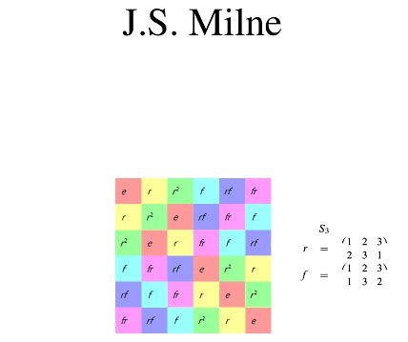
www.jmilne.org/math/CourseNotes/GT.pdf

Two other PDFs
Research magazine of Johannes Gutenberg University Mainz, 1986,
by Dieter Held

The classification of the finite simple groups

Script for the proseminar in winter term 2000/01 by Thomas Keilen, University of Kaiserslautern
Finite groups

Finite groups for
MINIMAL-Models
of geometry

PDF recommended by me by Prof. Siegfried Krauter
University of Education Ludwigsburg

Introduction to
finite geometry

Literature on group numbers for finite groups

Counting groups: gnus, moas and other exotica John H. Conway, Heiko Dietrich and E.A. O’Brien
www.math.auckland.ac.nz/~obrien/research/gnu.pdf
Department of Mathematics University of Auckland Auckland New Zealand

Table of number of groups for small orders
groupprops.subwiki.org/wiki/Table_of_number_of_groups_for_small_orders
groupprops.subwiki.org/wiki/Group_number_function
cameroncounts.wordpress.com/2016/05/20/more-groups/

There is otherwise an incredible amount of writing and videos on group theory, so I will refrain from giving further references.

When the music is over…
www.youtube.com/watch?v=VScSEXRwUqQ

This is the end, beautiful friend,
the very, very end

That ist the half of the so called symmetric group S₄ of order 24 (4! = 4x3x2x1 transformations).The A₄ has the same structure as the group GL₄(2) of the inversable $4×4$ – Matrixs over C₂, consisting only of the numbers zero (0) and the unit (1)
A group is simple if there is no normal subgroup. Because commucator-groups are normal, solvable groups are normal (if they are not cyclic C_{p} groups) But non-solvable groups too can be normal.
JEvery hamiltoninan grope has a subgrup isomorphic to Q₈ .

